Cloud Watch Logs

**Step:1**

Create a custom policy using JSON

{

"Version": "2012-10-17",

"Statement": [

{

"Effect": "Allow",

"Action": [

"logs:CreateLogGroup",

"logs:CreateLogStream",

"logs:PutLogEvents",

"logs:DescribeLogStreams"

],

"Resource": [

"*"

]

}

]

}

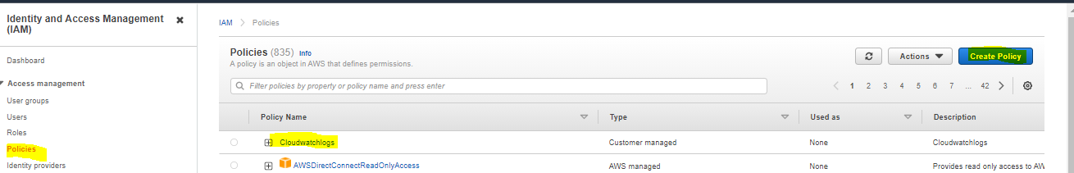

**Step:2**

Add that custom policy to the role

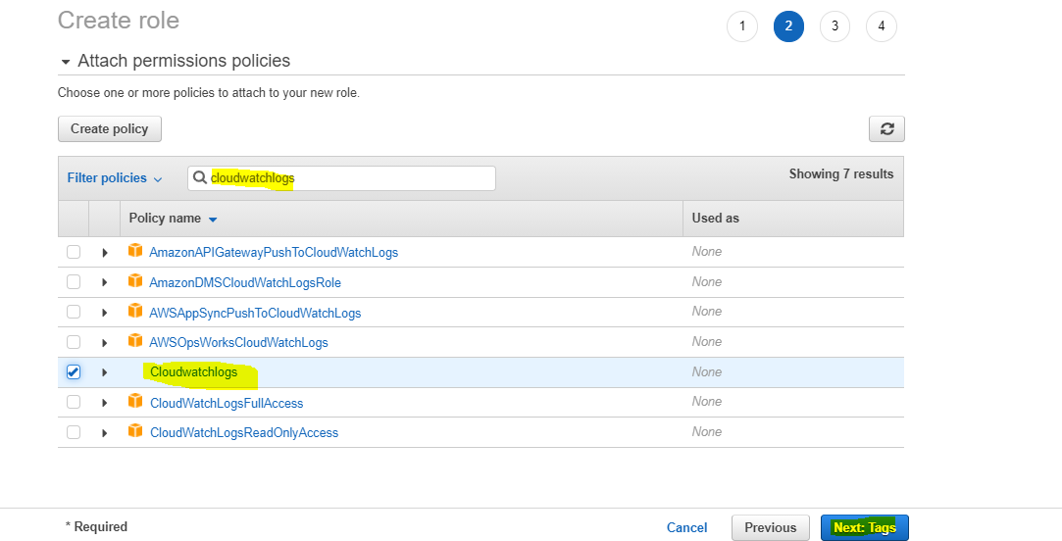

**Step:3**

Review the role and create it

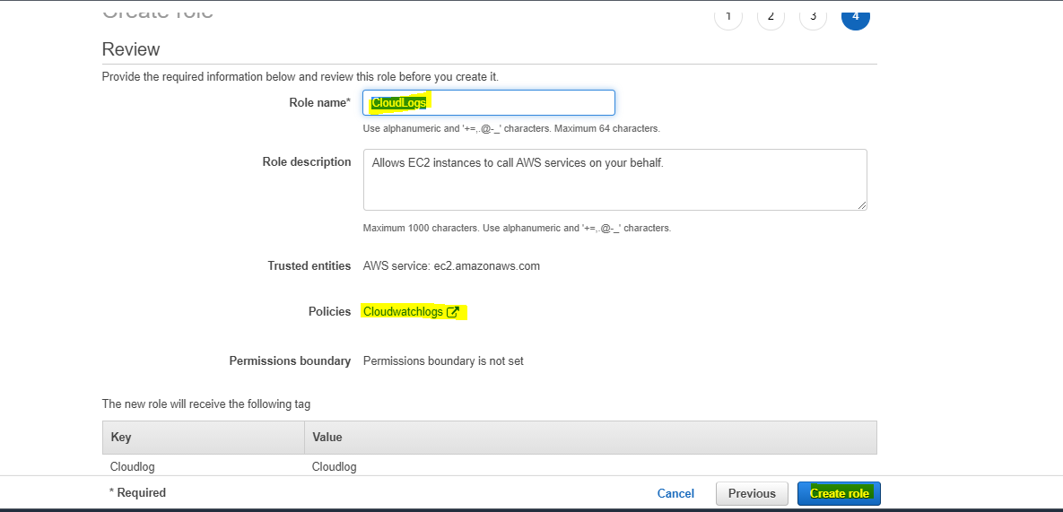

**Step:4**

Create a webserver allow port 80 and attach the IAM role to the particular server.

#!/bin/bash

sudo su

yum update -y

yum install httpd -y #apache

systemctl start httpd

systemctl enable httpd #server restart

echo "Hello i am from $(hostname -f) to check my cloudwatch log" > /var/www/html/index.html

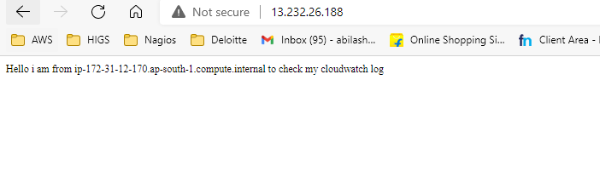

**Step:5**

Login to the server update and Install the awslogs package.

sudo yum update -y

sudo yum install -y awslogs

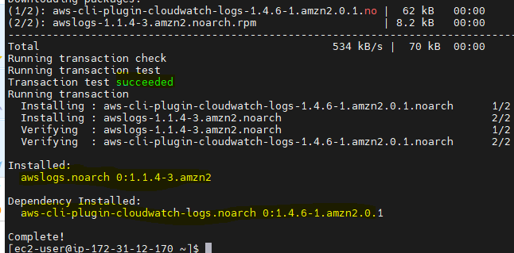

**Step:6**

* Edit the /etc/awslogs/awslogs.conf file to configure the logs to track.
* By default, the /etc/awslogs/awscli.conf points to the us-east-1 Region. To push your logs to a different Region, edit the awscli.conf file and specify that Region.

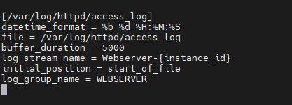

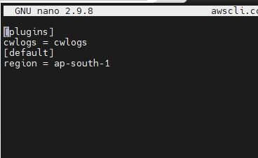

**Step:7**

If you are running Amazon Linux 2, start the awslogs service and enable it on system boot.

sudo systemctl start awslogsd

sudo systemctl enable awslogsd.service

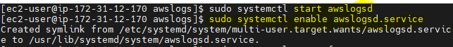

**Step:8**

Access the site and check the logs in the cloud watch logs section you can able to see the logs

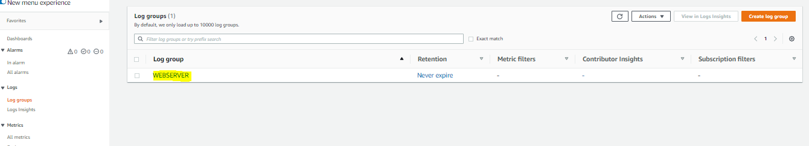

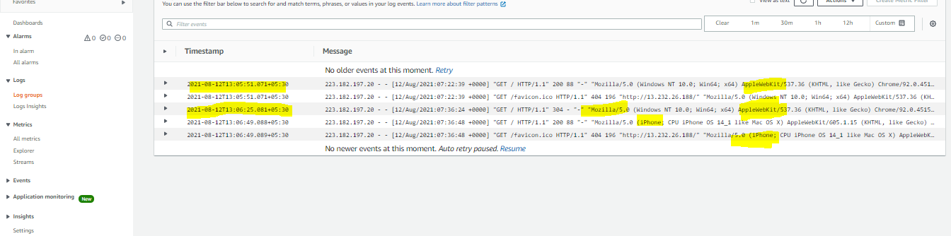

IT WORKS 😊